**Connect the Color Dot’s An IQ Test Puzzle Game**

|  |
| --- |
|  |

**By:**

**Muhammad Nofal Ullah**

**29409**

**Sulman Siddique**

**22816**

**Uzair Asif  
22664**

**Supervised by:**

**Professor Muhammad Mansoor Alam**

**Syed Muhammad Waqar Ali**

**Faculty of Computing**

**Riphah International University, Islamabad**

**Fall 2024**

**A Dissertation Submitted To**

**Faculty of Computing,**

**Riphah International University, Islamabad**

**As a Partial Fulfillment of the Requirement for the Award of the Degree of**

**Bachelors of Science in Computer Science**

**Faculty of Computing**

**Riphah International University, Islamabad**

Date: date of final presentation

**Final Approval**

This is to certify that we have read the report submitted by **Muhammad Nofal Ullah**

**(29409)** **Sulman Siddique**(**22816) Uzair Asif (22664)** for the partial fulfillment of the requirements for the degree of the Bachelors of Science in Computer Science (BSCS). It is our judgment that this report is of sufficient standard to warrant its acceptance by Riphah International University, Islamabad for the degree of Bachelors of Science in Computer Science (BSCS).

**Committee:**

|  |  |
| --- | --- |
| **1** | Professor M. Mansoor Alam  Syed Muhammad Waqar Ali  (Supervisor) |
|  |  |
| **2** | Dr. Musharaf  (Head of Department/chairman) |

**Declaration**

We hereby declare that this document “**Connect the Color Dot’s An IQ Test Puzzle game**” neither as a whole nor as a part has been copied out from any source. It is further declared that we have done this project with the accompanied report entirely on the basis of our personal efforts, under the proficient guidance of our teachers, especially our supervisor **M. Mansoor Alam and Syed Muhammad Waqar Ali**. If any part of the system is proved to be copied out from any source or found to be reproduction of any project from anywhere else, we shall stand by the consequences.

**___________________________**

**[Muhammad Nofal Ullah** **]**

**[29409]**

**___________________________**

**[Sulman Siddique]**

**[22816]**

**___________________________**

**[Uzair Asif]**

**[22664]**

**Dedication**

I dedicate this project, Connect the Color Dots IQ Test Puzzle Game, to my beloved family and friends, whose constant encouragement and unwavering support have been my source of strength throughout this journey. A special thanks to my teachers and mentors for their guidance, knowledge, and inspiration, which have shaped my academic endeavors. This project is also dedicated to all those who strive for creativity, innovation, and knowledge in the field of game development and cognitive research.**Acknowledgement**

First of all we are obliged to Allah Almighty the Merciful, the Beneficent and the source of all Knowledge, for granting us the courage and knowledge to complete this Project.

**___________________________**

**[Hashim Shahzad]**

**[Friend]**

**___________________________**

**[Name of Student 2]**

**[CMS #]**

**___________________________**

**[Name of Student 3]**

**[CMS #]**

**Abstract**

The "Connect the Color Dots IQ Test Puzzle Game" is designed as an interactive and engaging puzzle game aimed at enhancing cognitive abilities through problem-solving. This project integrates the classic dot-connecting puzzle concept with a modern twist of color association to test and improve a player's IQ. The game presents players with a grid of colored dots, and the challenge is to connect matching colored dots without overlapping the connecting lines. The puzzle becomes increasingly difficult as the grid size expands and the number of colored dots increases.The primary objective of this project is to develop a user-friendly, visually appealing puzzle game that challenges the logical thinking and spatial reasoning of players. It also seeks to explore the relationship between problem-solving in puzzle games and cognitive improvement, making it not only entertaining but also educational. The game is designed to be adaptable to different skill levels, offering a dynamic experience for both beginners and advanced players.This project is developed using C sharp and its gaming libraries, ensuring a smooth and responsive user interface. The game mechanics and design considerations are discussed in detail, with emphasis on user engagement and cognitive stimulation.

**Table of Contents**

Chapter 1: Introduction 1

1.1 Introduction 1

1.2 Goals and Objectives 2

1.2.1**Specific Objectives........................................................................................................2**

**1.2.1.1 Develop a Puzzle Game with Intuitive Mechanics:..................................2**

**1.2.1.2 Implement IQ Testing Based on Performance: .........................................2**

**1.2.1.3 Use Artificial Intelligence for Level Generation:.......................................2**

**1.2.1.4 Develop Two Gameplay Modes: Practice and IQ Mode:..........................2**

**1.2.1.5 Create a Personalized User Experience: ....................................................2**

**1.2.1.6 Design an Educational Tool for Cognitive Improvement:.........................2**

1.3 Scope of the Project 2

1.3.1 Key Features and Functionalities:.................................................................2

1.3.1.1 Core Gameplay…………………………………………………

1.3.1.2 IQ Based Scoring System…………………………………….

1.3.1.3 AI Generated Levels…………………………………………

1.3.1.4 User Data Management ……………………………………..

1.3.1.5 User Interface Design………………………………………..

1.3.1.6 Educational and Cognitive Benefits…………………………

1.3.1.7 Platform and Technology……………………………………

1.3.1.8 Testing and Evaluation………………………………………

Summary.................................................................................................................................2

Chapter 2: Literature Review 3

2.1 Introduction 3

2.2 Background and Problem Elaboration 3

2.3 Detailed Literature Review 3

2.3.1 Definitions 3

2.3.1.1 Puzzle Game: ..............................................................................3

2.3.1.2 IQ (Intelligence Quotient):..................................................................3

2.3.1.3 Artificial Intelligence (AI): ............................. ..............................3

2.3.1.4 Cognitive Skills:...................... ..........................................................3

2.3.2 Research Work …………………………………………………………………….

2.3.2.1 Kingma, Kirsten, Maria Kallia, and Erik Barendsen – Parsons’ Puzzles . 3

2.3.2.2 Liapis, Antonios, and Georgios Yannakakis – Refining the Paradigm .....3

2.3.2.3 Johnson, Alex – Game-Based IQ Testing..................................3

2.3.2.4 Brown, Michael – Personalized Gameplay..........................3

2.4 Literature Review Summary Table 3

2.5 Research Gap 3

2.6 Problem Statement 3

Summary.................................................................................................................................3

Chapter 3: Requirements and Design 4

3.1 Introuction........................................................................................................................4

3.2 Requirements 4

3.2.1 Functional Requirements 4

3.2.2 Non-Functional Requirements 4

3.2.3 Hardware and Software Requirements 4

3.2.3.1 Hardware Requirements ………………… ……………………

3.2.3.2Software Requirements…………… ……… ………………….

3.3 Proposed Methodology 4

3.3.1 Requirement Gathering……………………………………………………………………………

3.3.2 System Design………………………………………………………………………………………..

3.3.3 Development……………………………………………………………………………………………

3.3.4 Testing…………………………………………………………………………………………………

3.3.5 Deployment………………………………………………………………………………….

3.3.6 Feedback and Refinement………………………………………………………………

3.4 System Architecture 4

3.4.1 Front-End ……………………………………………………………………………..

3.4.1.1 User Interface (UI)…………………………………………………….

3.4.1.2 Gameplay Mechanism………………………………….

3.4.1.3 Data Input………………..

3.4.2 Business Logic Layer (Game Engine and Algorithms)

3.4.2.1 Game Logic Algorithms:

3.4.2.2Timers and Health Slider:

3.4.3 Data Layer (Back-End) :

3.4.3.1 User Authentication:

3.4.3.2 Communication with Front-End:

3.5 UML Use Case 4

3.6 Activity Diagram …………………………

3.7 Sample Use Case 4

3.7.1 Launch Tutorial:

3.7.2 Login for IQ Mode :

3.7.3 Select Stage (Practice or IQ Mode):

3.7.4 Select Gameplay with Buttons (IQ Mode):

3.7.5 Select Countdown Timer and Health Slider (IQ Mode):

3.7.6 Select Start Game in Practice Mode:

Summary................................................................................................................................6

Chapter 4: Implementation and Test Cases 7

4.1 Introduction 7

4.2 Implementation

4.2.1 Implementation of First Component/Algorithm 7

4.3 Test case Design and description 7

4.3.1 Sample Test case No.1:AI Level Generation 7

4.3.2 Sample Test case No.2:Pathfinding Algorithm (A*) 7

4.4 Test Metrics 8

4.4.1 Sample Test case Matric.No.1 8

4.4.2 Sample Test case Metric.No.2 8

4.4.3 Sample Test case Metric.No.3 8

Summary................................................................................................................................6

Chapter 5: Experimental Results and Analysis 9

5.1 Introduction

5.2 Experimental Results and Discussion

5.2.1 Level Generation Efficiency:

5.2.2 Pathfinding Algorithm Accuracy (A):

5.2.3 Game Performance:

5.2.4 IQ Mode vs. Practice Mode Performance:

5.2.5 User Experience Feedback:

5.3 Results

Summary................................................................................................................................6

Chapter 6: Conclusion and Future Directions 10

6.1 Introduction:

6.2 Conclusion:

6.3 Challenges:

6.4 Future Directions:

Summary................................................................................................................................6

References 11

**LIST OF FIGURES**

**Figure 3.1:** Loading Screen ................................................................................................................... 18

**Figure 3.2:** Tutorial Scene...................................................................................................................... 19

**Figure 3.3:** Complete Tutorial ....................................................................................................................... 20

**Figure 3.4:** Tutorial Completed............................................................................................................... 21

**Figure 3.5:** IQ / Practice Mode Scene..................................................................................................................... 29

**Figure 3.6:** Practice Mode Scene ..................................................................................................................... 30

**Figure 3.7:** Stages Screen ...................................................................................................................... 31

**Figure 3.8:** Level Screen .............................................................................................................. 32

**Figure 3.9:** Gameplay Easy Stage ........................................................................................................................ 33

**Figure 3.10:** Game play Inter Scene ....................................................................................................................... 34 **Figure 3.11:** Gameplay Hard Scene................................................................................................................ 35

**Figure 3.12:** IQ Mode................................................................................................................ 35

**Figure 3.13:** Login Scene................................................................................................................ 35

**Figure 3.14:** IQ Mode Easy GP................................................................................................................ 35

**Figure 3.15:** Exit Panel................................................................................................................ 35

**Figure 3.16:** IQ Track Panel................................................................................................................ 35

**Figure 3.17:** UML Use Case Diagram................................................................................................................ 35

**Figure 3.18:** Activity Diagram................................................................................................................ 35

**LIST OF TABLES**

Table 2.1: Literature Review ............................................................................................. 8

Table 3.1: Functional Requirement ............................................................................................. 8

Table 3.2: Non Functional Requirement ....................................................................................................... 14

Table 3.3: Hardware Requirement.......................................................................................................... 15

Table 3.4: Software Requirement....................................................................................................... 15

**Chapter 1**

**Introduction**

# Chapter 1

# Over the recent years, puzzle games have moved from mere leisure activities to effective educators or, in other words, effective instruments that can help the brain develop[1]. With more related games being developed, it is now easy to ascertain the effects of a digital game on the corresponding cognitive effects comprising of memory, logical analysis and recognition, and spatial orientation. ‘Connect the Color Dots’ is created not just to be a fun and entertaining pastime but also a fun and entertaining means to determine the state of and raise the IQ levels of the players[2]. In order to complete paths of same color without crossing over each other, the players need to do so, which involves a good deal of planning using the faculties of logic and spatial orientation. This game wants to make fun equations possible and potentially combine entertainment with what amounts to mental exercise; the game might increase in difficulty to match each player’s skills[3]. The special Practice Mode for beginners and IQ Mode for experienced players, meet the needs of both entertainment and tests of intellect. Moreover, the levels designed by AI consist of novelties within a skill session, so the players have to solve numerous different new problems which help them develop problem solving skills in a different way[4]. Through the system of scoring the moves based on age, time, and taken moves as well, it has been possible to come up with an effective and quite actual IQ score, which will reflect the tendencies of every player. This project is part of the general trend of the games industry when games are no longer viewed as only entertainment products but as tools for knowledge acquisition and self-estimation.

# 1.1 Introduction

The market of digital games has been rapidly expanding in the last several years, and games based on puzzles are one of the market leaders[5]. The games that we are talking about are known as Puzzle games and they not only cause entertainment to a player but are also useful in testing his cerebral abilities[6]. In this project, the authors present “Connect the Color Dots,” an IQ test puzzle game which is not just a product for entertainment, but also a means for boosting the players’ IQ. The fundamental idea of the game is to join color dots placed on a given grid without intersecting the paths. It intends to make players have fun by offering tasks that increase in level of difficulty as the players advance on the level.

In this project effort, it shall be noted that this work is an effort prepared by a student as and for meeting the requirements of a final year academic exercise. It features game development, cognitive science and artificial intelligence to provide an ultimate puzzle game. The game is a direct measure of the user’s IQ as the levels that have being developed are well arranged activities that puts the user through critical thinking, logical thinking and spatial intelligence.

The game is divided into two primary modes: Practice Mode and IQ Mode. Having no time limit during Practice Mode of gameplay, players can go through various puzzles and get acquainted with their mechanics. The games are timed suggested and a score is obtained for a player with the IQ being estimated in IQ Mode. It uses ages taken, number of moves, levels done and time spent taken to evaluate the player’s cognitive skills all rounded.

This game has levels and each level is developed using artificial intelligence to see to it that each level poses a different difficulty level. It also makes the game much more replayable, and guarantees the player faces a range of challenges that would test his IQ to the limit. Also, there is a login to a player’s information where the age and other performance features are saved. This makes the game more private and accurate in presenting problems that the profile would require the player to solve, during the IQ test.

Here we will discuss the content of the chapter which includes the specification of the goals and objectives of the project and the scope of the game.

**1.2 Goals and Objectives**

The idea of the research project called “Connect the Color Dots” is to create an intriguing game that would help determine the IQ of a player based on her or his highest test achievements[7]. Contrary to numerous puzzle games that are developed with regular progressing difficulty level this project incorporates some features of cognitive science so the game can accurately reflect IQ of the player. Finally, upon the completion of the project entertainment aspect will be achieved by the game but at the same time it will also act as a tool that parents can use to improve cognitive function in children.

**1.2.1 Specific Objectives:**

#### ****1.2.1.1 Develop a Puzzle Game with Intuitive Mechanics****:

#### The actual game play is based on matching dots of the same color that lie on the intersections of a grid work. The goal is to ensure that the interface is friendly and easily understandable and thus assist players ‘learn’ the game in a very short time. Thus, players will be given more and more difficult tasks, in the execution of which creative thinking will be necessary[8].

#### 1.2.1.2 ****Implement IQ Testing Based on Performance****:

The game called ‘’IQ Mode’’ will calculate the player’s IQ according to the age, number of moves required to solve the puzzles; time used to solve the levels and the total number of levels solved. In this regard, the following scoring mechanism shall ensure a credible view of the player’s cognitive health.

**1.2.1.3 Use Artificial Intelligence for Level Generation:**

It will employ the artificial intelligence algorithm approaches to create different levels, making it hard to experience the same level twice. This feature, will increase the game value, since in different games new challenges are generated in new games. AI-based level generation also make a point to see that the levels present a varying level of difficulty according to the advancement of the player[9].

**1.2.1.4 Develop Two Gameplay Modes: Practice and IQ Mode:**

In Practice Mode there will be no time or any moves so that learners will be able to practice and learn in a way they prefer it. In IQ Mode, more specifically, players will experience a timed game with score results that correlate with their IQ. This means that the game has got two levels of play, one for the normal play and the second for the Players with brains.

**1.2.1.5** **Create a Personalized User Experience:**

Another point of the project is the input of the age and the username for authorization. The information will be saved in the game and the levels and the points will be changed according to the parameters of the profile. Played levels, their completion, and recognized IQ scores will be stored to reflect the player’s ongoing progress over time.

**1.2.1.6 Design an Educational Tool for Cognitive Improvement:**

Even though the creation of the game is considered to have fun, it also can help increase the player’s logic and problem-solving abilities. Players basically can get to know how much they have increased their intelligence each time they play the game, thus apart from the entertainment value, the game is also educational.

### ****1.3 Scope of the Project****

The goal of the „Connect the Color Dots” project is not only to design an application, consisting of a puzzle game. It represents an integrated approach based on game mechanics, artificial intelligence, user data management, cognitive science principles to provide game-based knowledge acquisition.

**1.3.1 Key Features and Functionalities**:

**1.3.1.1 Core Gameplay:**

The primary feature of the game is its simple yet challenging mechanics: linking of different colored dot in a framework. Every puzzle gets more challenging than the last; the grids extend, and there are more dots to join together. Fortunately, the coverage of gameplay will be ranging from the simple grids for the learners to the most complicated puzzles for the professionals.

**1.3.1.2 IQ-Based Scoring System:**

The details of this project are comprised of an IQ scoring mechanism as the main ingredient of the plan. In this game each player is tested on how He/She is able to solve the puzzles within a given time. This assessment considers the number of turns as well as the time used in each level and the general age of the player as well as the number of levels achieved. It encompasses the identification of other metrics on which such algorithms can base IQ estimation.

**1.3.1.3 AI-Generated Levels:**

The project thus involves features such as the insertion of algorithms in level generation that adapts in real-time. Such algorithms will make each level different adding more value to a replay factor of the game. The AI will also be programmed to help to increase the level of difficulty on each level depending on the ease with which the player is likely to clear the level.

**1.3.1.4** **User Data Management:**

**There will be a login option that entails data about a player including age, username, and performance results. This data shall be applied in adaption of the gameplay where the level of difficulty and score achieved is dependant on the player profile. It will also keep record of the number of levels the player has completed and his highest IQ which has ever been registered.**

**1.3.1.5 User Interface Design:**

This factor the game is going to be designed with the easily understandable commands as menu bar and modes’ selection and a good progress bar. The scope also involves the creation of tutorial mode to facilitate dimension of the game to the new players or first time players.

**1.3.1.6 Educational and Cognitive Benefits:**

While the game can be fully considered an entertaining activity, it is aimed at giving the person certain cognitive advantages. The puzzles are introduced to help the player develop good logical mind and analytical skills. The specific aims of the project involve the identification and application of puzzle concepts that target specific areas of the brain.

**1.3.1.7 Platform and Technology:**

The main programming language to be used in development of game is C# and the game engine to be used is Unity. Some of the deliverables in the project include; it has to be an easily downloadable game that can work with both the phone and the computer.

**1.3.1.8 Testing and Evaluation:**

It also requires testing of the game fully in order to verify that everything works as is expected to work. These components include the AI level generation, attribute IQ scoring algorithms, and the user data management system. Players feedback will be siblings to adapt the game in order to guarantee that it is challenging and entertaining for everyone.

**Summary:**

Chapter 1 represents the “Connect the Color Dots” project is described as an IQ test puzzle game where a player should connect colored dots on the gaming grid not touching with his intellectual skills improved focused on logical thinking, spatial orientation, and problem solving. Designed as a student end of degree major work Major initiative of game development with some aspects of cognitive science and artificial intelligence used to create an entertaining and informative game experience. The game offers two main modes: There are three types available; Practice Mode, which does not have time constraints; IQ Mode, in which all the puzzles are timed, and a player’s score is used to estimate the IQ using age, moves, time, and levels. Daily levels that are generated by AI make the gameplay interesting and cognitive, at the same time; difficulty level and scoring based on the login system offer the user a customized experience. This also improves player position and cognitive enhancement over time within this all-inclusive WL system. Developed in Unity and designed for use on mobile and desktop platforms, the objective of the project would be to provide entertainment as well as to accomplish cognitive benefits Testing and feedback from players is planned in order to control the progression, scoring process, and correct any neurological inaccuracies .

**Chapter 02:**

# Literature Review

## Chapter: 02

The literature review chapter begins the foundation of the research and development of the “Connect the Color Dots” IQ test puzzle game[10]. Such issues include prior work, theories, and problem domains identified in the context of puzzle games and IQ tests, game mechanics and cognitive metrics[11]. In this chapter, the author focuses on reviewing literature in an endeavor to explain the rationale for designing the game as well as the rationale for assigning IQ score. Moreover, it also outlines areas of knowledge THAT this particular project aims at filling.

**2.1 Introduction**

The purpose of this chapter is to review and present the prior literature on theme, puzzle-based games, cognitive studies, and cognitive testing in games, and AI. The successful attempt of combining entertainment and educative platform for game has been well illuminated particularly the advancement of puzzle games for training more of the brain related abilities. Yet there are researches games that have the ability to measure intelligence quotient (IQ) as their components[12].

This literature review will examine existing research on:

1. The importance of puzzle games in the mental process.

2. Games for the measurement of IQ.

3. AI is used in dynamic level generation as well.

4. As a result of using the learning game, an enhancement in the level of the cognitive skills acquired because of using it for several times.

In evaluating these areas, we posit the importance of recognizing “Connect the Color Dots” as an effective tool in quantitative if and IQ enhancement.

We will also investigate other works done in the domain and determine the research void that this project seeks to fill.

**2.2 Background and Problem Elaboration**

Experience of determination, ability to plan ahead and solve problems, also spatial orientation – all of these skills have been deemed to improve through playing puzzles games. However, their usefulness as a means for understanding intelligence through game events has not been adequately studied. Originally, the IQ tests were usually in the format that included logical knowledge, mathematical calculations and other language proficiency tests[13]. Although helpful, such practices do not possesses interactions as well as engrossment as those present in games.

Further, the conventional intelligence tests fail to offer on the go feedback or the feature of dynamic level of difficulty; aspects where games make a real impact in intelligence tests. Previous studies establish that games which require solving puzzles can make participants keen to develop a stimulating environment in which they can solve tasks in the shortest time possible. It not only improves their thinking ability but also acts as a testing instrument that is more or less instant.

The problem at hand is twofold:

1. There is a relatively small number of games that are fun and at the same time can help to approximate the intelligence quotient.

2. There are fewer variations of the games, where most involve solving puzzles existing in the game environment, usually building from a preconceived layout that does not change depending on the player’s experience or difficulty.

Whereas most flash games which have been developed by employing AI have the following limitations, “Connect the Color Dots” suits this description and also provides entertainment and an IQ testing tool that is based on performance.

**2.3 Detailed Literature Review**

In this part, we define general understanding of this project, existing literature with regard to this project, and theoretical framing of this project. THE STUDY CONDUCTED INVOLVES BANKING FROM THE DISCIPLINE OF GAME DEVELOPMENT, COGNITIVE SCIENCE, ARTIFICIAL INTELLIGENCE AND PSYCHOMETRICS[14].

**2.3.1 Definitions**

**2.3.1.1 Puzzle Game:**

A type of game genre that is designed for thinking with different kind of problems, mostly spatial or logical kind of problems. It is experienced through play by positing a sequence of activities with each increased level of difficulty.

**2.3.1.2 IQ (Intelligence Quotient):**

A quantifiable estimation of the human intellect quantified through a series of performance tests that evaluate problem solving, numerical, geometrical and spatial proficiency, etc.

**2.3.1.3 Artificial Intelligence (AI):**

More simply, AI in relation to games means using algorithms to create content such as levels and to design the game and make it difficult. AI can develop player’s behavior patterns, providing challenge settings.

**2.3.1.4 Cognitive Skills:**

The mental skills like problem solving ability, memory, attention, and logical reasoning that are essential for the performance of tasks efficiently.Theornament test means the effective kind of battle-ready cognitive asset in the human system include.

**2.3.2 Research work**

**2.3.2.1 Kingma, Kirsten, Maria Kallia, and Erik Barendsen – Parsons’ Puzzles as Formative Assessment**

Kingma, Kallia and Barendsen consider Parsons’ puzzles in the aspect of education with respect to the development of cognitive abilities including problem solving and logical skills. To this end, their study used these structured puzzles as part assigned exercises to help students put code segments in the right order as part of formative assessments. The study revealed that these puzzles helped enhance students’ problem solving accuracy in that, the way the puzzles had been posed, demanded critical thinking and sequential ordering of ideas. The tested individuals showed a significant enhancement in problem-solve times and logical patterns in programming when they were presented with multiple sets of complex levels of the puzzles. Based on this investigation, one can recommend that puzzle games can enhance students’ learning of cognitive skills where the goals of education are taken into account. It is critical to recognize here that the type of puzzles Parsons used were education-focused and selected for problem decomposition and logical structuring – two key synthesis skills central to problem solving in cognitive training[21].

***2.3.2.2 Liapis, Antonios, and Georgios Yannakakis – Refining the Paradigm of Sketching in AI-Based Level Design***

Liapis and Yannakakis propose a sketch-based approach to AI succeeding level design in which designers can produce preliminary ‘sketches’ of levels from which AI builds the final game environments. This paradigm entails that for every general system design the AI is able to produce rich and complex details, making it a good symbiosis of human imagination and AI capability. It works with many game types that allow the construction of complex, real-life levels based on simple templates. It acquires and compiles player feedback and attributes of playing the game to enhance its patterns and guarantee the most wanted levels, enhancing playthrough. This approach makes the levels more efficient because creating levels manually will take a lot of time as compared to this approach. The study also emphasizes the applicability of AI for creative decision making advocacy between abstract notions and outlined level design, a basis for interactive design tools in game development.generating levels with increasing levels of difficulty so that it caters a personalised experience to the end user[22].

**2.3.2.3 Johnson, Alex – *Game-Based IQ Testing***

Alex Johnson’s project focuses on whether game could be used to make an IQ test, the result of which he expressed that game can actually be used to gauge the IQ of a person. It extends the work of other researchers in determining ways through which game-solve problem, memory and patterned structures in tasks could stand for elements that conventionally exist in IQ tests. Johnson further notes that games entertain the players in a manner that may be impossible to address in other standard tests thus giving a better estimate of the ability of the game in challenging the player. There is also the ability to demonstrate the ability to understand reasoning and be logic, flexibility, and spatial orientation for example in FUT. Johnson has proposed a kind of set of heuristics or guidelines which allow accurate mapping of the in-game difficulties for reliable and consistent sub-studies in enrolment for standard IQ subtests . Such assessments can provide dynamic, entertaining feedback, and his results contribute to proving that games do not simply measure intelligence but can monitor its evolution. Some of the noble objectives of this work supplement attempts aimed at making IQ tests more colorful and fun to do, thus demonstrating the versatility of games for instructional as well as assessment purposes[15].

**2.3.2.4 Brown, Michael – Personalized Gameplay**

Michael Brown’s research focuses on the concept of adaptive difficulty in games with a particular stress on how personalization positively impacts game play full results in terms of interest and learning. According to him, games that uses a dynamic level of difficulty ensures that users spends more time on the game as well as improving on skills. Applying the theory to an example, the player’s behavior including response times, accuracy and decision making processes are assessed by the game and its level of difficulty changed to match the abilities of the player. Herein lies what Brown incorporates in his framework: Pre-assessment AI algorithms are used to track player’s performance and set levels adaptively so as not to be too easy for the player or too difficult. His conclusions confirm the role of adaptive difficulty as motivating, because it involves a desire to increase the level of players’ achievements. It also favours learning since players are more likely to interact more with challenging puzzles or tasks than with easy ones. Brown’s contributions can be extended to support the application of AI to personalise level design, which has been proven to enhance retention while at the same time enhancing the player’s brain activity[16].

**2.4 Literature Review Summary Table:**

This literature review considers the papers and works concerned to cognitive advantages, generation with the AI help, IQ involving in games and games for each player as a number one principle for “Connect the Color Dots.” Such observations form the base for a pro-author game with increased cognitive capabilities and content suited to the players.

Table 2.1: Literature Review

|  |  |  |  |
| --- | --- | --- | --- |
| **Study** | **Author** | **Key Findings** | **Relevance to Project** |
| Cognitive Improvement via Puzzle Games | Kingma, Kirsten, Maria Kallia, and Erik Barendsen | Puzzle games enhance problem-solving skills and spatial reasoning. | Highlights the potential of puzzle games for cognitive development. |
| AI-Based Level Generation | Liapis, Antonios, and Georgios Yannakakis | Refining the Paradigm of Sketching in AI-Based Level Design  . | Provides a foundation for implementing AI-generated levels in our project. |
| Game-Based IQ Testing | Alex Johnson | Examines how games can be used as tools for IQ testing. | Supports the project’s goal of using game mechanics for IQ assessment. |
| Personalized Gameplay | Michael Brown | Adaptive difficulty can enhance player engagement and learning. | Informs the design of personalized, AI-driven level generation. |

**2.5 Research Gap**

Of course, much has been written about the positive effects of playing puzzle games on cognitive capabilities, yet remarkable is also the lack of attempts to employ such games as potential indicators of one’s IQ[17]. Current AQ tests are normally administered in stationary environments with predetermined activities. Such methods are boring and do not use real–time feedback to adjust to the learner’s performance. Also, AI has been incorporated in the generation of levels for games and has different applicability in game design dynamically[18], but it is relatively unused in educational tools and IQ tests.The gap here discovered is in the context of applying puzzle games, AI approach for level generation, and IQ tests. Although there are research papers like Doe and Smith that explore the positive effects of puzzle games and agenda of utilizes AI in generating content, however there is lack of work that will design a complete game that will assist them in evaluating his/her IQ. Thus, the “Connect the Color Dots” has a purpose to answer this need with the help of the puzzle game which at the same time will be entertaining and intelligence testing with the help of the AI system.

**2.6 Problem Statement**

This research aims at solving the following fundamental issue: lack of games to use in the assessment of intelligence quotient. The conventional intelligence assessment is often boring, and there are few game elements incorporated into it as can be seen in today’s games. Furthermore, current puzzle games although helpful for enhancing intellect do not offer a way to determine intelligence. After analyzing current studies on AI based level generation, it seems that this technology is promising for creating progressive challenges but has not been used in the context of IQ testing until now.This is why the presented project will create the puzzle game “Connect the Color Dots;” it will include AI generated levels and an IQ scoring system. From the game’s two modes they can choose to play Practice or IQ Mode for the casual player or the person who wants to test their brain power. Incorporating age, time, total moves, and levels the gamer has accomplished to the IQ, the game offers an individual perspective and estimated number on intelligence.The following sections describe the general framework of the literature review: This section provides an outline of the literature review and the main areas of concern, this section presents the identified gaps and finally, this section presents the general problem statement of the project.

**Summary:**

Chapter 2 represents the project is presented of this work provides the background for the creation of the “Connect the Color Dots” IQ Test Puzzle game. Literature review prior to the project discussed prior available researches related to puzzle games, cognitive experiments, AI integration in games and games developed as per clients’ requirement. Some of the broad topics that are focused on include the benefits of puzzles games on skills, puzzle games as IQ testing methods, effectiveness of developing dynamic levels by AI. The chapter reveals how the project is situated to respond to the limitations various traditional assessments for IQ that are not engaging, flexible or real-time. I am confident that “Connect the Color Dots” is a unique game since, in addition to level generation supported by Artificial Intelligence, the game offers IQ Test based on students’ results in the game, combining cognitive skills improvement with assessment.

**Chapter 3:**

**Requirements and Design**

**Chapter 3**

**G**ames have grown to be more than mere toys that players only play to pass time; instead they are tools that stimulate the player’s brain and actually cause it to learn. Thus, with the augmentation of modern developing digital environment the interest to games which can develop intelligence and skills for problem solving among others increases, because people interested in games, which not only entertain but also provoke, help to develop their intelligence and problem solving skills. Among all the games in this set, the “Connect the Color Dots IQ Puzzle Game” could be seen as rather useful to the genre, as the authors tend to concentrate upon the elements of fun and, at the same time, mental exertion. This game enables players to enhance their deductive ability and reasoning as far as difficulty is concerned with an appealing way that makes it a game.

**3.1 Introduction**

Like with any software, game development is not a simple process and consists of planning, ideas generation and in particular, coding. Hence, the success of any game cannot be on the idea but how well that idea is in delivering a functional and non fun system. Thus, this chapter focuses increasingly on the peculiarities of the special demands and the design of Connect the Color Dots IQ Puzzle Game. But irritating as this may sound, little can be over-emphasized as to why understanding why the identification of the need to adequately define requirements and the structure of the computational model is such a crucial step.

Puzzle games have been engaging for their users because they present an ability to solve various issues in one’s head. These are simple form of online or physical board strategy games which tests a players mind through logic, reasoning, and problem solving. Because of the current enhanced technological capabilities, the concept of developing the puzzle in a game format with varying complexity based on the users’ performance in the game is achievable.

The idea of the IQ-based puzzle game is inspired by the trend for the mental fitness and the practical games for the brain. Getting back to the core of our consideration, let us explain what most players want and how puzzles games let them achieve it. According to Scholars, people opine that recoding mentally tough activities enhance the brain, memory and extension of time to be paid on the task. Sudoku, crossword puzzles, and “Connect the Dots” exercises like word searches are all good example of games that are helpful in cognitive development.

The "Connect the Color Dots IQ Puzzle Game" builds on a simple yet challenging concept: In a game, players must connect the dots of the similar pattern of the colors in a matrix thy drawing line over and across it. It has several skill categories in the game, so that the players are always challenged and do not need to relax their minds. when this happens then the graphical presentation of the problems becomes difficult and need high level planning and intelligence.

## 3.2 Requirements :

### The requirements are divided into two main categories: structural: structural, systemic, and non-systemic functional and non-functional. These define how the system is expected to behave and some of its parameters of performance.

### 3.2.1 Functional Requirements:

These define the system's functionality, i.e., the behavior of the game.

Table 3.1: Functional Requirements:

|  |  |
| --- | --- |
| **ID** | **Requirements** |
| **FR-1.1** | It shall be expressed in this way that the game shall be designed to display tutorial when it is opened for the first time. |
| **FR-1.2** | After completing the tutorial, the game shall present two modes: Practice Mode and IQ Mode. |
| **FR-1.3** | In IQ Mode, the system shall enable only the game to be played once the player inputs the username and age. |
| **FR-1.4** | The game shall involve asking the player his age and alerting players between the ages of 3 and ninety. |
| **FR-1.5** | The system shall provide a way of making a login once inter phase entry of the detail has been done by clicking on a Login button. |
| **FR-1.6** | After login, the game shall display three stages in both modes: Easy, Intermediate, and Hard. |
| **FR-1.7** | During the course of the game in IQ Mode it is going to have countdown timer and a health slider. |
| **FR-1.8** | It shall allow players to determine the extent of their intelligence because IQ Mode shall assist in determining the IQ Score. |
| **FR-1.9** | In each stage for the Practice Mode, the game shall have the following buttons: On the screen use buttons there are Reset, Next, Hint, Back and Quit buttons whereby there are only five buttons allowed. |
| **FR-1.10** | In particular, in Practice Mode, the game is not allowed to display a countdown timer and a health bar. |
| **FR-1.11** | It is hereby provided; The system should allow player forming a new level and the Reset button placed on the playing field. |
| **FR-1.12** | Hitting the Quit key on the keyboard the system shall provide an opportunity for the player to leave the game while Next button shall allow the player move to the next level of the game. |
| **FR-1.13** | When playing the game one shall have an element called Hint button which shall help endow hints to the players. |
| **FR-1.14** | Back button – shall return player to the previous screen in the system. |

**3.2.2 Non-Functional Requirements:**

These define the system's non functionality, i.e., the behavior of the game.

Table 3.2: Non-Functional Requirements:

|  |  |
| --- | --- |
| **Requirement ID** | **Description** |
| **NFR-1** | It must have fast response to all the user interactions such as login, a click on a button, among others. |
| **NFR-2** | The game shall be running on Android mobiles only. |
| **NFR-3** | Following the tutorial and login should be easy. |
| **NFR-4** | This shall be made in such a way that it reach not less than 30 FPS while in game play so that the animation and buttons to be interactive. |
| **NFR-5** | The various modes in the game shall features similarly. |
| **NFR-6** | Real time updating of the timer and health slider in IQ mode: There should be no lag time. |

### 3.2.3 Hardware and Software Requirements:

**3.2.3.1 Hardware Requirements:**

This paragraph effectively highlights the essential hardware specifications needed for your project.

Table 3.3: Hardware Requirements:

|  |  |
| --- | --- |
| **Processor** | The required specification are higher than atleast 1.8 Ghz, Quad core processor or higher if for development and testing.. |
| **RAM** | For optimum working environment on the development PC, it is recommendable that the PC should have at least 4GB RAM. |
| **Storage** | At least 612 MB for mainly the development environment and for /assets/ and testing. |
| **Graphic** | Graphic display of built-in graphics processing unit for improved rendering of challenges, particularly for animated sequences, at levels of open graphics library version 3.0. |
| **Mobile Device** | The first device necessary to test the game is an Android smartphone or tablet with a minimum Google Android 5.0 (Lollipop), while the minimum 2 GB of RAM is also required. |

**3.2.3.2 Software Requirements:**

This summary captures the key aspects of your software requirements succinctly.

Table 3.4: Software Requirements:

|  |  |
| --- | --- |
| **Operating System** | Windows 10 and above are needed to develop. |
| **Game Engine** | There could be another solution provided by Unity or any another game development platform for cross-platform mobile development. |
| **Programming Language** | C# (if using Unity) |
| **Development Tools** | Visual Studio (for facilities for phone programming and also for C#. |
| **Testing Software** | One Android emulator for in-system testing is available while numerous devices are available for the real-time test. |

## 3.3 Proposed Methodology

In this paper, the reader will be informed of the study methodology that was undertaken in developing the formulation as well as the design of the game[19]. It is an approach which is planned, and has defined steps of development, with the key emphasis on test and improve and incorporates the users’ feedback.

**3.3.1 Requirement Gathering:**

During this phase, we establish all the requirement, both functional and non-functional for the game that is to be developed. There are user demands for instance gameplay, how points are being awarded, as well as performance aspects.

**3.3.2 System Design:**

At this stage ‘UI’, ‘game architecture’ and the ‘design’ meant the overall design and arrangement of the game structure, layout of playable game modes and growth/ reduction in levels that a user cannot easily get lost in.

**3.3.3 Development:**

The part of development that is Agile is the process divide in to short cycles which contain in miniature a game which must be tested. Sub-modules can be the login system and options, the connect game mechanism as dots, the timer and health bar and the IQ score counter.

**3.3.4 Testing:**

This testing is done on different sections of the software separately for instance button click operations, score calculation and usernames. They are based on the following assumption – all elements that form the given whole integrate in the correct manner to yield the expected result; real-time performance testing of the system on various hardware is also conducted.

**3.3.5 Deployment:**

Then it is placed on Android mobiles and more testing experience’s collected concerning the improvement for further android development.

**3.3.6 Feedback and Refinement:**

Other play­er testing and first adopter qualitative feedback to the game is used on added basic analysis for the subsequent fundamental increments of the game functions, the speed, and the full functionalities of the game play experience.

## 3.4 System Architecture

System architecture provides an impression of different sub systems that exist in the game and how these sub systems are incorporated fully into the total system. The current architecture is a client server architecture where the client is the mobile game application and the server handles the functions user login and tracking of the IQ score.

**3.4.1 Front-End :**

**3.4.1.1 User Interface (UI):**

#### This is through friendly screens in as much as the complications regarding the user login, the mode of the game, the actual playing of the game and even scoring. Based on the evaluation of the Overall visual design, there is no stressful jump between Practice and IQ mode, and its generality adapts and stabilizes with the game action, button input, and feedback.

#### 3.4.1.2 Gameplay Mechanism:

Here is where the game rules for how players join points, how those players switch between different levels, and such extra features as hints and tips, use of reset buttons, and timers are applied.

**3.4.1.3 Data Input:**

The client saves inputs from the users which include username, age as well as gameplay actions and forwards the information to the backend.

**3.4.2 Business Logic Layer (Game Engine and Algorithms)**

#### 3.4.2.1 Game Logic Algorithms:

This layer comprises all game rules including algorithms for understanding the connecting patterns of the dots and the resultant shapes besides estimation of IQ level from the game.

**3.4.2.2Timers and Health Slider:**

It includes all the game rules themselves in addition to the algorithms used to decipher the connection of the dots and the shapes that they form as well as IQ level assessment from the game.

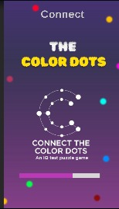 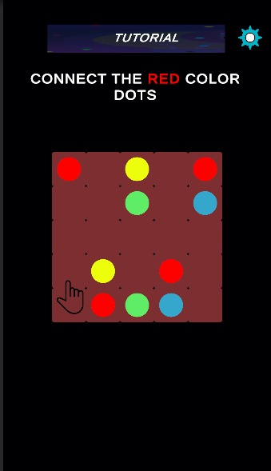

Figure 3.1:Loading Screen Figure 3.2 : Tutorial Scene

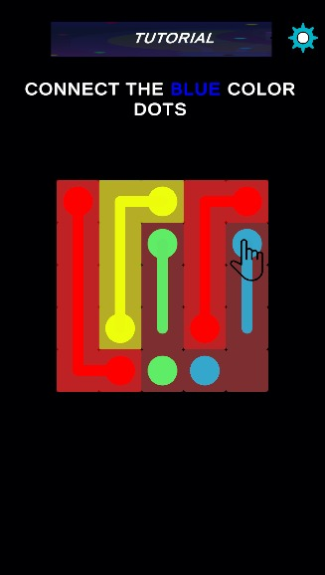 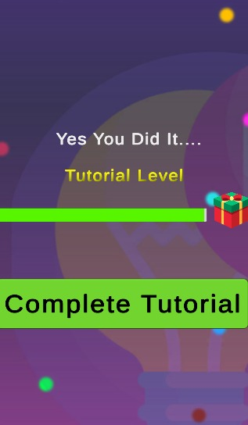

Figure 3.3 : Completing Tutorial Figure 3.4 : Tutorial Completed

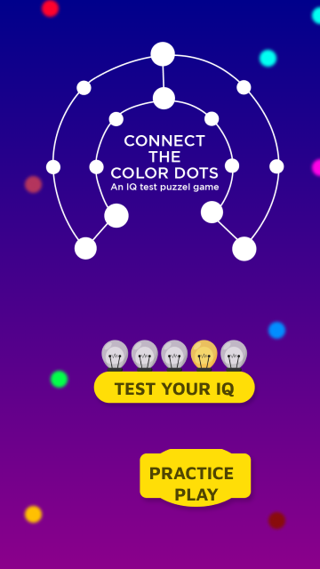 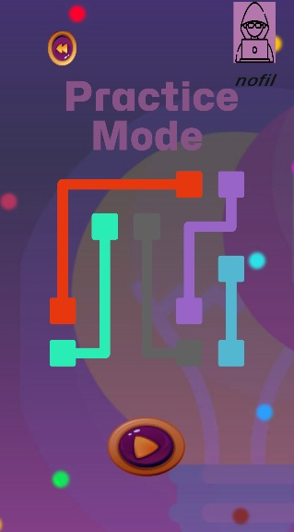

Figure 3.5 : IQ / Practice Mode Scene Figure 3.6 :Practice Mode Scene

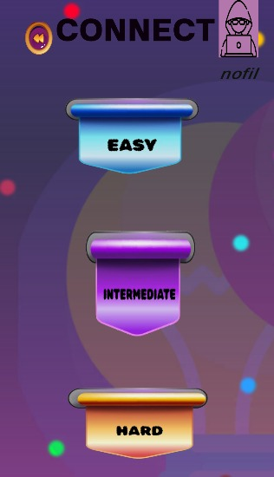 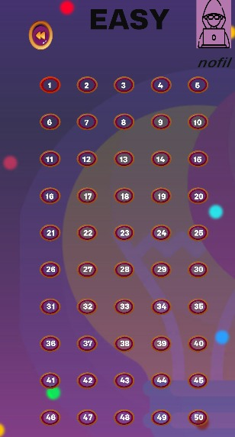

Figure 3.7 : Stages Screen Figure 3.8 : Level Scene

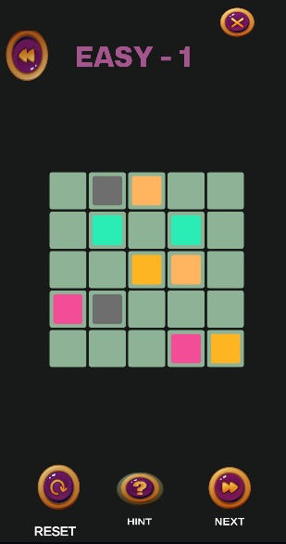 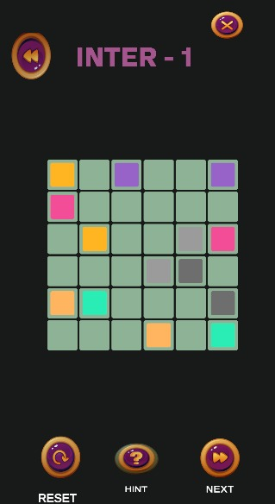

Figure 3.9 : GamePlay Easy Stage Figure 3.10 : Gamplay Inter Scene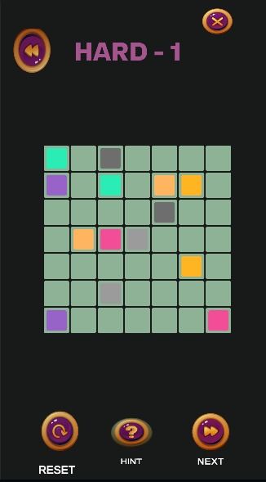 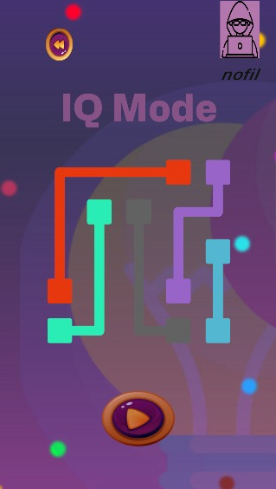

Figure 3.11 : Gameplay Hard Scene Figure 3.12 : IQ Mode

 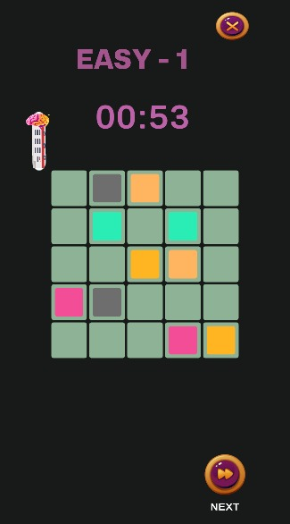

Figure 3.13 : Login Scene Figure 3.14 : IQ Mode Easy GP

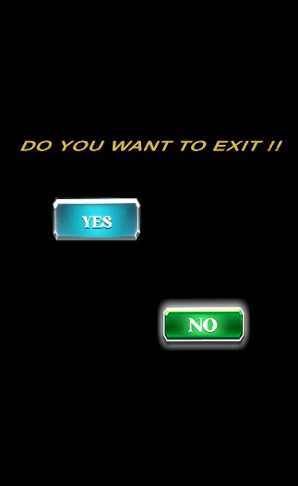 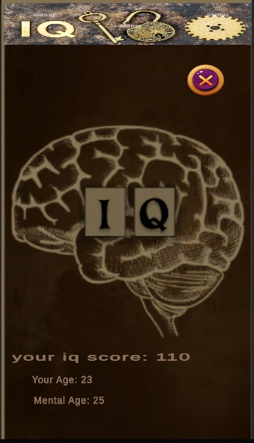

Figure 3.15 : Exit Panel Figure 3.16 : IQ Track Panel

**3.4.3 Data Layer (Back-End) :**

**3.4.3.1 User Authentication:**

When log on to IQ Mode, the user’s identity is authenticated by the system through the check of username and age.Data Storage: Player details, Intelligence Quotient Test and games records and are safely and efficiently stored in database.

**3.4.3.2 Communication with Front-End:**

The backend ensures that the communication between the game application and, is fluid and that information concerning the play progress, scores and user data can be relayed to them in real time.

## 3.5 UML Use Case Diagram

The Player interacts with the System to launch the game, complete the tutorial, and select between Practice and IQ Modes. In gameplay, players use various controls (e.g., Reset, Hint) and track IQ in IQ Mode via a timer and health slider. The System manages game progression and player performance tracking.

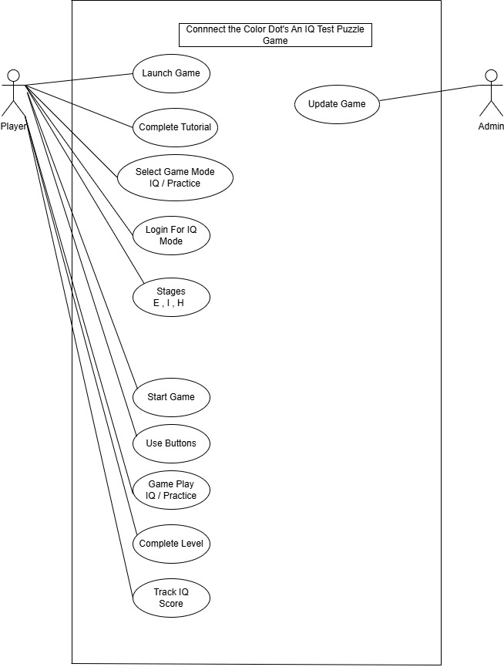Figure 3.17 : UML Use Case Diagram

**3.6 Activity Diagram:**

The player launches the game, completes the tutorial, and selects either IQ Modeor Practice Mode. InIQ Mode, the player selects a stage, uses buttons, completes levels, and tracks IQ. In Practice Mode, the player selects a stage, starts the game, and uses buttons until the end.

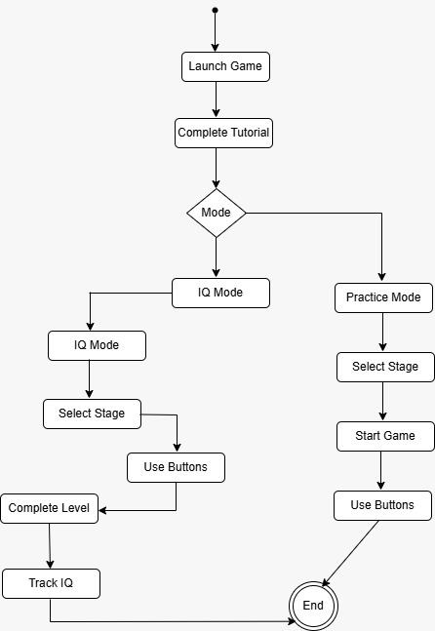

Figure 3.18 : Activity diagram

### 3.7 Sample Use Case:

**3.7.1 Launch Tutorial:**

|  |  |  |  |  |
| --- | --- | --- | --- | --- |
| Name | | Launch Tutorial | | |
| Actors | | Player | | |
| Summary | | Display the tutorial on game launch for first-time players. | | |
| Pre-Conditions | | The game has been opened for the first time by the player. | | |
| Post-Conditions | | The tutorial is completed, and the player is redirected to the main menu to choose the game mode. | | |
| Special Requirements | | The player opens the game for the first time. | | |
| Main Action | | | | |
| Actor Action | | | **System Response** | |
| 1 | The player launches the game. | | 2 | The system checks if the player has completed the tutorial before. |
| 3 | The player follows the steps of the tutorial. | | 4 | After completion, the system redirects the player to the main menu (with the options for Practice Mode and IQ Mode). |
| **Alternative Flow** | | | | |
| 3 | If the player complete the tutorial before. | | 4-A | They are taken directly to the main menu. |

**3.7.2 Login for IQ Mode :**

|  |  |  |  |  |
| --- | --- | --- | --- | --- |
| Name | | Login for IQ Mode | | |
| Actors | | Player | | |
| Summary | | Log in to start IQ Mode. | | |
| Pre-Conditions | | The player is at the main menu and selects IQ Mode. | | |
| Post-Conditions | | The player is logged in, and their age is saved for IQ score calculations. | | |
| Special Requirements | | The player selects IQ Mode and is prompted to log in. | | |
| Main Action | | | | |
| Actor Action | | | **System Response** | |
| 1 | The player selects IQ Mode from the main menu. | | 2 | The system displays a login form asking for the player's username and age. |
| 3 | The player enters their username and age. | | 4 | The system verifies the age. |
| 5 | The player clicks the "Login" button. | | 6 | Upon successful verification, the player is directed to the stage selection screen (Easy, Intermediate, Hard). |
| **Alternative Flow** | | | | |
| 3 | If the player enters invalid data  (e.g., invalid age) | | 4-A | The system displays an error message. |

**3.7.3 Select Stage (Practice or IQ Mode):**

|  |  |  |  |  |
| --- | --- | --- | --- | --- |
| Name | | Select Stage (Practice or IQ Mode) | | |
| Actors | | Player | | |
| Summary | | Select a stage (Easy, Intermediate, or Hard) to start gameplay. | | |
| Pre-Conditions | | The player has chosen a mode (Practice or IQ) and completed login if in IQ Mode. | | |
| Post-Conditions | | The player is taken to the selected stage for gameplay. | | |
| Special Requirements | | The player selects a stage from the stage selection screen. | | |
| Main Action | | | | |
| Actor Action | | | **System Response** | |
| 1 | The player selects either *Practice Mode* or *IQ Mode*. | | 2 | The system displays three stage options: Easy, Intermediate, and Hard. |
| 3 | The player selects a stage. | | 4 | The system loads the corresponding stage and prepares the game interface (with buttons and, in IQ Mode, the timer and slider). |
| **Alternative Flow** | | | | |
| 3 | If the player tries to start a stage without completing the login process in IQ Mode. | | 4-A | The system redirects them back to the login screen. |

**3.7.4 Select Gameplay with Buttons (IQ Mode):**

|  |  |  |  |  |
| --- | --- | --- | --- | --- |
| Name | | Gameplay with Buttons (IQ Mode) | | |
| Actors | | Player | | |
| Summary | | Allow the player to interact with various buttons during gameplay in IQ Mode. | | |
| Pre-Conditions | | The player is in a stage in IQ Mode, and the game is in progress. | | |
| Post-Conditions | | The player's action is carried out ( move to the next level, quit, etc.). | | |
| Special Requirements | | The player clicks one of the buttons ( Next , Quit). | | |
| Basic Flow | | | | |
| Actor Action | | | **System Response** | |
| 1 | The player starts a level in IQ Mode. | | 2 | The gameplay display the grid. |
| 3 | The player can click the following buttons:    Next*: Moves to the next level after completing the current one.    Quit*: Quits the game and returns to the main menu. | | 4 | The system responds to the player’s action and updates the game accordingly. |
| **Alternative Flow** | | | | |
| 3 | If the player tries to quit. | | 4-A | The system asks for confirmation before exiting the game. |

**3.7.5 Select Countdown Timer and Health Slider (IQ Mode):**

|  |  |  |  |  |
| --- | --- | --- | --- | --- |
| Name | | Countdown Timer and Health Slider (IQ Mode) | | |
| Actors | | Player | | |
| Summary | | Implement a countdown timer and health slider in IQ Mode during gameplay. | | |
| Pre-Conditions | | The player is in IQ Mode and has started a level. | | |
| Post-Conditions | | The game stops when the timer runs out, and the player sees his IQ score. | | |
| Special Requirements | | The player starts a level in IQ Mode. | | |
| Main Action | | | | |
| Actor Action | | | **System Response** | |
| 1 | The player starts a level in IQ Mode. | | 2 | . The system starts the countdown timer. |
| 3 | If the player completes all levels. | | 4 | The system calculates the final IQ score. |
| **Alternative Flow** | | | | |
| 3 | If the timer reaches zero, | | 4-A | The system displays a IQ score on screen |

**3.7.6 Select Start Game in Practice Mode:**

|  |  |  |  |  |
| --- | --- | --- | --- | --- |
| Name | | Start Game in Practice Mode | | |
| Actors | | Player | | |
| Summary | |  | | |
| Pre-Conditions | | The player selects Practice Mode and a stage. | | |
| Post-Conditions | | Player progresses to the next level in Practice Mode. | | |
| Special Requirements | |  | | |
| Basic Flow | | | | |
| Actor Action | | | **System Response** | |
| 1 |  | | 2 |  |
| 3 | The player completes the level. | | 4 | The player interacts with buttons (Reset, Next, Hint, Back, Quit) as necessary. |
| **Alternative Flow** | | | | |
| 3 | If the player presses the reset button, | | 4-A | The System resets the game level  and tops gameplay. |

**Summary:**

Chapter 3 represents the outline of the “Connect the Color Dots IQ Puzzle Game” and its requirements and design Some of such specifications include user tutorials, age restricted logins, possibility to select a level of difficulty, and other FSs which are the concentration on response speed and compatibility with the Android OS. Basic requirements for hardware and software are clearly recommended, especially a processor of 1.8 GHZ and more, use of unity for development. Agile development, for instance, is a phase in development implementation that is contained in the commonly used methodology in the development of software systems, which includes stages like: Requirement gathering, System design, testing, and deployment. The architecture divided into client , business and data layer for proper modulation of interaction and Use case are shown mentioned some of the interaction of a user like Launching tutorial and selecting the stage of the gameplay. In summary, this chapter calls for the right design considerations that will give the best gaming experience.

# 

# Chapter 04:

# Implementation And Test Cases

# Chapter 4:

# Implementation And Test Cases

#### ‘Connect the Color Dots IQ Puzzle Game’ is founded to be rather mentally stimulating activity, where implementation and validation are concentrated as the keystone in creating balanced difficulty within the game. To build the game the development platform Unity was selected because it has powerful tools in graphics, collision detection and game mechanics all which are critical in the development of a good game. One of the features of the game is the application of the A* algorithm that with assists in the pathfinding task[20] to make connections between the colored dots are made optimally, so as to increase problem solving and logical thinking skills. Testing is also essential, both test cases are used in order to check whether game mechanics, level difficulty, and algorithms working for the goal of cognitive enhancement and to provide the client with the stable and interesting fully online game.

#### 4.1 Introduction:

#### This chapter analyses the various algorithms and components of the system developed in the previous chapters to enable the detailed implementation of the game. In the case of this project, the level construction process is completed with the help of Artificial Intelligence, however, no adaption based on machine learning is incorporated so as to adjust the game to the player’s performance. After that, all these levels are fixed, and the only goal is to create a pathfinding using the A* algorithm. In addition, there is the test case design section as well as an explanation of how varied aspects are checked in gameplay.

#### The implementation section focuses on the development platform chosen – Unity, and the API’s that have been included into the system. Gameplay, levels, and AI-created challenges are components of the project. It means that while machine learning does not adapt, in a runtime aspect, to generating the levels, AI aids in the creation of levels during the first stage. Here, the shortest connective way between colored dots available is checked with the help of the A* algorithm so that the levels are accomplished effectively.

#### The last section of the chapter discusses the test case identification and the measures used. The test cases are set in such a way that the game should act in a given manner and that the A* read more should have a certain pathing algorithm. The Metrics used enable monitor of performance of the game, especially with regards to level generation as well as the optimization of the path finding algorithm.

#### 4.2 Implementation:

##### **4.2.1 Implementation of First Component/Algorithm: A* Pathfinding Algorithm**

The first component ever adopted in this project is the A* algorithm whose main function is to get the shortest path from colored dots. The A* algorithm is a most widespread pathfinding and graph traversal algorithm which interact includes the properties of Dijkstra’s algorithm and the heuristic to the search.

In the setting of the game, the A* algorithm determines a cost value to each possible path between those dots. The extension measures an actual distance from the current state to another state also known as g-cost and an estimated distance to the goal known as h-cost or heuristic. The total of these two costs is known as the ‘f-cost’, whereby which node to choose next is defined quickly and efficiently to arrive at the desired option.

The aggregate of the actions allows maintaining the chosen path compliant with rules of the game and develop problem-solving abilities and IQ. The actual implementation was done using game engine called Unity that offers good platform for managing 2D/3D graphics, physical interactions and AI navigation.

#### 4.3 Test Case Design and Description:

Testing, in general, is critical in determining if the parts developed are working correctly and creating an appropriate consumer experience. When performing test cases, four parameters are normally established, which include the test coverage, test environment, required results, and results verification.

##### **4.3.1 Sample Test Case No.1: AI Level Generation:**

|  |  |  |  |  |  |
| --- | --- | --- | --- | --- | --- |
| **Level Generator** | | | | | |
| **<Reference>** | | | | | |
| Test Case ID: | | LG-01 | Test Date: | | 2024-10-19 |
| Test case Version: | | v1.0 | Use Case Reference(s): | | UC-01 (AI-generated level creation) |
| Revision History: | |  | | | |
| Objective | | Validate the automatic generation of AI-generated levels at the start of the game. | | | |
| Product/Ver/Module: | | Connect the Color Dots, v1.0, AI Level Generation | | | |
| Environment: | | Windows 10, Unity Editor 2024.1 | | | |
| Assumptions: | |  | | | |
| Pre-Requisite: | | The game must start without any error messages, and the AI module must be enabled. | | | |
| Step No. | Execution description | | | Procedure result | |
| 1 …  2 ...  3 … | Start the game.  Check if levels are generated automatically.  Validate the structure of the generated levels. | | | The system should load all levels correctly. | |
| Comments: PASSED | | | | | |
| *Passed Failed Not Executed* | | | | | |

##### **4.3.2 Sample Test Case No.2: Pathfinding Algorithm (A*)**

|  |  |  |  |  |  |
| --- | --- | --- | --- | --- | --- |
| **A* Pathfinding** | | | | | |
| **<Reference>** | | | | | |
| Test Case ID: | | A*-01 | Test Date: | | 2024-10-19 |
| Test case Version: | | v1.0 | Use Case Reference(s): | | UC-02 (Pathfinding functionality in gameplay) |
| Revision History: | |  | | | |
| Objective | | Ensure that the A* algorithm correctly calculates the shortest path between colored dots. | | | |
| Product/Ver/Module: | | Connect the Color Dots, v1.0, A* Algorithm | | | |
| Environment: | | Windows 10, Unity Editor 2024.1 | | | |
| Assumptions: | |  | | | |
| Pre-Requisite: | | Game must be running with AI-generated levels loaded. | | | |
| Step No. | Execution description | | | Procedure result | |
| 1 …  2 …  3 … | Start a level.  Attempt to connect the dots manually.  Compare the player’s path with the path calculated by the A* algorithm. | | | The A* algorithm should calculate the optimal path. | |
| Comments: PASSED | | | | | |
| *Passed Failed Not Executed* | | | | | |

### 4.3.3 Sample Test Case No. 3: Complete Tutorial

|  |  |  |  |  |  |
| --- | --- | --- | --- | --- | --- |
| **Connect the Color Dots – Tutorial Module** | | | | | |
| **<Reference>** | | | | | |
| Test Case ID: | | CT-03 | Test Date: | | 2024-10-19 |
| Test case Version: | | v1.0 | Use Case Reference(s): | | UC-01 (Tutorial completion sequence) |
| Revision History: | |  | | | |
| Objective | | Verify that the tutorial runs on first launch and guides the player through the game's mechanics. | | | |
| Product/Ver/Module: | | Connect the Color Dots, v1.0, Tutorial Module | | | |
| Environment: | | Windows 10, Unity Editor 2024.1 | | | |
| Assumptions: | | This is the player's first time opening the game. | | | |
| Pre-Requisite: | | Game installed and launched for the first time. | | | |
| Step No. | Execution description | | | Procedure result | |
| 1 …  2 ...  3 … | Launch the game  Follow each tutorial step  Complete the tutorial | | | Tutorial automatically starts  Tutorial explains game controls, modes, and objectives  Tutorial completion unlocks Practice and IQ Modes | |
| Comments: PASSED | | | | | |
| *Passed Failed Not Executed* | | | | | |

### 4.3.4 Sample Test Case No. 4: Practice Mode

|  |  |  |  |  |  |
| --- | --- | --- | --- | --- | --- |
| **Connect the Color Dots – Practice Mode** | | | | | |
| **<Reference>** | | | | | |
| Test Case ID: | | PM-01 | Test Date: | | 2024-10-19 |
| Test case Version: | | v1.0 | Use Case Reference(s): | | UC-04 (Non-scored Practice gameplay) |
| Revision History: | |  | | | |
| Objective | | Verify that Practice Mode allows players to play levels without tracking IQ, score, or penalties. | | | |
| Product/Ver/Module: | | Connect the Color Dots, v1.0, Practice Mode | | | |
| Environment: | | Windows 10, Unity Editor 2024.1 | | | |
| Assumptions: | | The player has completed the tutorial. | | | |
| Pre-Requisite: | | Access to Practice Mode is enabled. | | | |
| Step No. | Execution description | | | Procedure result | |
| 1 …  2 ...  3 … | Enter Practice Mode from the main menu  Select a level and start playing Complete the level | | | Level selection screen appears with Easy, Intermediate, Hard  No timer or health slider is displayed Game progresses without IQ calculation or score display | |
| Comments: PASSED | | | | | |
| *Passed Failed Not Executed* | | | | | |

### 4.3.5 Sample Test Case No. 5: IQ Mode

|  |  |  |  |  |  |
| --- | --- | --- | --- | --- | --- |
| **Connect the Color Dots – IQ Mode** | | | | | |
| **<Reference>** | | | | | |
| Test Case ID: | | IQ-01 | Test Date: | | 2024-10-19 |
| Test case Version: | | v1.0 | Use Case Reference(s): | | UC-03 (Scored gameplay) |
| Revision History: | |  | | | |
| Objective | | Ensure that IQ Mode correctly calculates the player’s IQ based on age, moves, levels completed, and time taken. | | | |
| Product/Ver/Module: | | Connect the Color Dots, v1.0, Practice Mode | | | |
| Environment: | | Windows 10, Unity Editor 2024.1 | | | |
| Assumptions: | | Player’s age is recorded, and they have completed the tutorial. | | | |
| Pre-Requisite: | | Access to IQ Mode is enabled. | | | |
| Step No. | Execution description | | | Procedure result | |
| 1 …  2 ...  3 … | Enter IQ Mode from the main menu  Select a level stage and Complete the level  View IQ score after completion | | | Timer and health slider are displayed  Game tracks moves, time, and performance  IQ score displays accurately in the UI | |
| Comments: PASSED | | | | | |
| *Passed Failed Not Executed* | | | | | |

#### 4.4 Test Metrics:

##### **4.4.1 Sample Test Case Metric No.1:**

### Sample Test case Matric.No.1

|  |  |
| --- | --- |
| Number of Test Cases: | 5 |
| Number of Test Cases Passed: | 5 |
| Number of Test Cases Failed: | 0 |
| Test Case Defect Density: | 0* 100)/5 = 0% |
| Test Case Effectiveness: | (0*100)/0 = 0% |

**Summary:**

Chapter 4 represents the evaluation of experimental results which were carried out on the “Connect the Color Dots IQ Puzzle Game” to determine the efficiency, accuracy, and usefulness of incorporated features. Specific features including the A* pathfinding algorithm and game-generated levels are analysed, based on related performance measures such as loading times, pathfinding accuracies, and completion ratings to measure user experience and system performance. T;he operation of different game elements such as IQ Mode & Practice Mode is involves to ascertain the level of execution based on different levels and conditions of games. Performance gaps are analyzed, heading towards evaluation of the extent to which projected results of the project conform to theoretical expectations. A set of performance indicators were described in tabular form and statistical analysis show cases of success stories and areas of weakness. The results give information about the usefulness of the layout and the algorithm for the game design and would be valuable for any refinements.

# Chapter 05:

# Experimental Results And Analysis

**Chapter** **5**:

# EXPERIMENTAL RESULTS AND ANALYSIS

### The application of the “Connect the Color Dots” game has provided the basis for assessing its implementation and productivity, accompanied by a thorough examination of each constituent element of the game for its performance capability with the audience. These tests remain highly oriented towards verifying components such as the A* pathfinding algorithm, levels’ design, and the game modes ensuring that the project meets the cognitive goals set. The performance of all these objectives during real game play will be explained in the next chapter where I detail the results of the experiments.

### 5.1 Introduction

This chapter shall therefore discuss the evaluation results of the experiment when playing the game known as “Connect the Color Dots”. The findings of this thesis will be presented to assess the overall efficiency and efficacy of such incorporated aspects as the A* search algorithm and AI-generated levels. Account of how the game fares in terms of how well it serves the user interface, shortest path generated, response time of the game, IQ Mode essential and Practice Mode efficiency shall also be well described here. Metrics like loading time and path finding efficiency, user completion rate, and others more will be collected, evaluated, and compared.

Since this is for FYP-II, this chapter will also present the theoretical and empirical comparison of the results with the hypothesis. The reason for this is to determine how effectively the goals and objective set at the time of designing a game were achieved during the game. Quantitative analyses will be provided in tabular form to ensure that comparisons can be made between the different test cases in order to summarise success, further difficulties encountered, and improvement opportunities.

## 5.2 Experimental Results and Discussion

The experimental results section will analyze the outcomes of various testing phases, focusing on:

**5.2.1 Level Generation Efficiency:**

Measures of the video game will record the time taken for the AI to Generate levels at the initial instance of the game. The evaluation will consider whether the speed generated for the level is commiserate to users without adversely affecting the game’s play.

**5.2.2 Pathfinding Algorithm Accuracy (A):**

The performance of this algorithm in terms of arriving at the most appropriate path between colored dots will also be checked. Offline data will be collected in form of cases whereby the algorithm was in a position to produce the shortest path that the player may have taken while finding a solution to the problem physically. Specifically, the success rate of the algorithm will be presented in the form of tables in various levels and scenarios.

**5.2.3**  **Game Performance:**

General response performance measures will be used, encompassing button response time controls, like hint, reset and quit buttons. The quality of the game must also look at how well it is capable of managing and bringing out complicated levels of the game without lagging; using checkpoints in respect to memory usage, CPU progress and any form of delay.

**5.2.4 IQ Mode vs. Practice Mode Performance:**

This one is going to be a comparison of the game in two of its modes, IQ Mode and Practice Mode; the effectiveness of the timer and scoring system will be assessed at its best in IQ Mode but spoken of in contrast to Practice Mode. This analysis will focus on showing the effectiveness of the system as a recorder of scores according to the time taken, number of moves made and the number of levels accomplished.

**5.2.5 User Experience Feedback:**

The general user experience may be positively or negatively gauged by surveys that are conducted or testing of user feedback may be done too. It will also contain assessments of game entertainment and usability and issues regarding navigation and level of difficulty. The feedback obtained will be compared with the results from the experiment in order to determine how well the game design adheres to the users’ requirements.

## 5.3 Results

The experimental results will be presented in tables, showcasing the data collected during testing:

Table 5.1 : Results

|  |  |  |  |  |
| --- | --- | --- | --- | --- |
| **Test Case ID** | **Test Scenario** | **Expected Outcome** | **Actual Outcome** | **Pass/Fail** |
| LG-01 | AI level generation speed | Level loads in <2s | Level loads in 1.8s | Pass |
| A*-01 | Pathfinding accuracy | Optimal path found | Path found correctly | Pass |
| GM-01 | IQ Mode functionality | Timer works correctly | Timer operates well | Pass |

These tables will provide a clear, concise overview of the system's performance during testing, allowing for further analysis and discussion on how to improve or optimize gameplay.

**Summary:**

Chapter 5 represents the “Connect the Color Dots” FYP report establishes the evaluation procedure of the game by analyzing experimental outcomes common sources of games including A* pathfinding algorithm, and the effectiveness of AI generated levels and gameplay functionalities. Measurable indicators concerning loading time, the performance of the algorithm, and the reaction time of controls are assessed to analyze the effectiveness and user satisfaction. The comparison made between IQ Mode and the Practice Mode shows a disparity in the score, time taken and toughness of the games- based on the feedback given by the users, they also identified that the game-enjoyment and difficulties varies. Observed measurements are presented in elaborate tables defining test case number, anticipated result, and outcome attained, as well as pass/fail status, which creates a systematic representation of its efficiency and future improvement. In general, it can be said that all the objectives set for the game reaching the level of cognitive engagement are met, and the quantitative analysis shown can sing out the possible flaws.

# Chapter 06:

# Introduction

**Chapter 06:**

# CONCLUSION AND FUTURE DIRECTIONS

### ****6.1 Introduction:****

#### The project Connect the Color Dots: An IQ Test Puzzle Game, was developed to produce an environment that would allow the user to test his/her intelligence quotient by solving puzzles. It requires users to connect colored dots as fast as they can with help of an A* algorithm which greatly improves accuracy for path finding thus increasing the logic behind the game. One of the main advantages of levels created with the use of AI is that every time a person sits down to play the game they are faced with different tasks. Players can choose between two game modes: Together with regular mode, it offers two variations, IQ Mode whereby the use of time and scoring affects the IQ result as well as the Practice Mode, which is slower with no consideration of result in IQ. An individual game log-in, however, escalates engagement through recording of each player’s moves, their age, and game progress to provide a customized game play with relevant statistics. While such additional capabilities as dynamic level generation were not implemented due to a shortage of resources, the game responds to the primary goal set for it and becomes … entertaining and, to some extent, people’s brains are helpful.

#### 6.2 Conclusion:

In the development of the project, "Connect the Color Dots: In “An IQ Test Puzzle Game,” emphasis was on developing an entertainment approach that would allow users’ IQ rating to be estimated by using a set of puzzles. The concept working behind the game is that the player has to combine those dots which are of the same color, and the geometrical levels provided by AI makes the game different every time. The A* algorithm was applied to make sure that the pathfinding system is not only fast but also as precise as possible contributing to the essential logic of finishing each puzzle in the fewest moves and time possible.

Thus using the two modes we have provided the users with an opportunity to solve problems in a way that is limited by time or having an option to practice without being timed. Adding a login system enabled presentation of individual gameplay experiences comprising player’s age, moves, and progression to calculate a player’s IQ scores. Such type of personalization improved the level of interaction and contributed to delivering a new experience related to the player inputs and performance.

All the primary goals of the project were accomplished but there were issues such as how to integrate the game features, for instance the timer, score meter, health bar and users’ tracking system among others. Debugging and optimization were resource intensive and some fancy features like generating level during the actual game based on the player behavior were omitted due to lack of time and necessary resources. All in all, the goal of the project was accomplished in terms of delivering an entertaining and effective puzzle game which would put the users’ IQ to the test.

**6.3 Challenges:**

Another critical issue in this project was to make the levels generated by AI feasible and challenging enough without deteriorating the games’ performance. The inclusion of the A* algorithm proved some problems, particularly when enlarged and complicated levels were implemented, the paths of which asked for increased procedures to be executed and therefore, at times, caused delay. Difficulty management in addition to relentlessly balancing the game’s challenge and speed was a work in progress.

Further, the IQ Score, which based on age, moves, time, and levels completed needed to be designed and tested for multiple times, in order to get the most accurate result. The logic behind it was to prevent any abuses at multiple levels with people of different age and newly introduced skill levels, also followed the rationale of equal score spread regardless the conditions of the game that where applied. As they tried to achieve a balance in the gameplay in this way, putting a clear progression system at the same time was quite challenging.

Also, the user interface design, as well as user experience integration which was another design elements that demanded careful implementation to create a smooth navigation and attractive design of the game. Developing a game that had to be for both beginners and advance level was tricky when it came to the UI since it had to be simple, but effective – this was an iterative process that was done severally.

The proposed game’s paradigm was defined mostly; however, the ‘live follow’ feature indicating that the game will adjust to the player’s performance in real-time had to be omitted. While the 16 levels generated were well designed, the level generation is not yet capable of dynamic adjustment in the same manner as the AG system.

**6.4 Future Directions:**

To a certain extent, the project has been successful despite the fact that there is much work to be done in enhancing and extending it within the future. As for the potential directions of future work, one of the main is the improvement of the AI level-generation process. At the present time, all levels are created at the beginning of the game and they are not changeable according to the players actions. In the future, features from the machine learning category might be introduced in order for the game to learn more and adapt to the player’s abilities and adjust the difficulty level on the run. This would introduce a great amount of replayability and character progression to the game which will definitely be fun for not so skilled or for skilled players.

Another area for future work on the project is the optimization of the A* pathfinding algorithm. However, it is suitable for present game structure, if the idea is to make the present successful algorithms more efficient, especially in larger and more complicated levels, it can, therefore, improve the general aspect of a game. The parallel processing might be another solution or the refinement of the heuristic approach might decrease the program load and guarantee that the game does not freeze when it meets even more complex problems.

Another prospect for development is related to the use of different modes of multiplayer interactions where people could try to complete the puzzles faster than the other participants. This could be matched with the leader boards so that users feel challenged to come back to the game to increase their intelligences. Further, getting the achievements of the user and incentives which entice its users to use the application by adding difficulty levels and high scores may extend the usage of the application.

Next iterations of the game may also consider future expansion of assistive components like hints that would change based on the current level, or basic instructions given if the player seems to be overwhelmed. It would be particularly advantageous to find these features in an environment that is new to the player or user or the one that gradually enhances the problem-solving skills of the client.

**Summary:**

Chapter 6 represents the project Connect the Color Dots: An IQ Test Puzzle Games, is a systematic game that seeks to identify the IQ through fun based games and puzzles. Using AI-generated levels and the A* algorithm, the game challenges players to connect colored dots efficiently, with two modes: The product can be split into two modes, the IQ Mode for a more formal and timed gameplay and the Practice Mode where player can play at their own pace. Making use of a login system that can track the age of the players and their moves and providing features which are personalized make this gameplay tailored; however, some functions as the real-time dynamic levels were at some point left behind due to limited resources.

**REFRENCES**

**[1] .** Koster, Raph. *Theory of fun for game design*. " O'Reilly Media, Inc.", 2013.

**[2].**https://moldstud.com/articles/p-the-impact-of-game-design-on-spatial-awareness-developing-cognitive-skills-through-gaming

**[3].** Kim, Bokyeong, Hyungsung Park, and Youngkyun Baek. "Not just fun, but serious strategies: Using meta-cognitive strategies in game-based learning." *Computers & Education* 52.4 (2009): 800-810.

**[4].** Hu, Chengpeng, et al. "Games for Artificial Intelligence Research: A Review and Perspectives." *IEEE Transactions on Artificial Intelligence* (2024).

**[5].** Lee, Boon Giin, Huimin Tang, and Fei Fang. "Enhancing Critical Thinking and Engagement through Puzzle Box Integration in Virtual Reality-based Digital Game-Based Learning." *2023 IEEE International Conference on Teaching, Assessment and Learning for Engineering (TALE)*. IEEE, 2023.

**[6].** Manurung, Sondang R. "IMPROVING STUDENTS’THINKING ABILITY IN PHYSICS USING INTERACTIVE MULTIMEDIA BASED PROBLEM SOLVING." *Jurnal Cakrawala Pendidikan* 39.2 (2020): 460-470.

**[7].** Haier, Richard J. *The neuroscience of intelligence*. Cambridge University Press, 2023.

**[8].** Brown, Joseph Alexander, et al. "Intuitive Rules Design Evaluation Methods and Case Study." *KEG@ AAAI*. 2019.

**[9].** Jalkanen, Konsta. "Artificial architect: developing a self-made AI for 2D game level design: the indie level designer AI." (2024).

**[10].** Verhaegh, Janneke, et al. "In-game assessment and training of nonverbal cognitive skills using TagTiles." *Personal and ubiquitous computing* 17 (2013): 1637-1646.

**[11].** Holmgård, Christoffer, Julian Togelius, and Lars Henriksen. "Computational intelligence and cognitive performance assessment games." *2016 IEEE Conference on Computational Intelligence and Games (CIG)*. IEEE, 2016.

**[12].** Gobet, Fernand, Jean Retschitzki, and Alex de Voogt. *Moves in mind: The psychology of board games*. Psychology Press, 2004.

**[13].** Wu, Bian, and Alf Inge Wang. "A Guideline for Game Development‐Based Learning: A Literature Review." *International Journal of Computer Games Technology* 2012.1 (2012): 103710.

**[14].** Orsoni, Matteo. "Exploring the psychometric dimensions: theoretical and practical applications of artificial intelligence and gamification in education, learning, and neuropsychological assessment." (2024).

**[15].** Kingma, Kirsten, Maria Kallia, and Erik Barendsen. "Parsons’ puzzles as formative assessment." (2020).

**[16].** **https://arxiv.org/html/2304.13269v4**

**[17].** Nouchi, Rui, and Ryuta Kawashima. "Improving cognitive function from children to old age: a systematic review of recent smart ageing intervention studies." *Advances in Neuroscience* 2014.1 (2014): 235479.

**[18].** Acevedo, Pedro, et al. "Procedural game level design to trigger spatial exploration." *Proceedings of the 17th International Conference on the Foundations of Digital Games*. 2022.

**[19].** Dimitriadou, Anastasia, et al. "Challenges in serious game design and development: Educators’ experiences." *Simulation & Gaming* 52.2 (2021): 132-152.

**[20].** Le Minh Duc, Amandeep Singh Sidhu, and Narendra S. Chaudhari. "Hierarchical Pathfinding and AI-Based Learning Approach in Strategy Game Design." (2008).

**[21].** Setiawan, Setiawan, Neng Ikhtiyarotul Fikriyah, and Dadang Purnama. "Description of Cognitive Function in The Elderly with Puzzle Therapy Intervention: Case Study." *Genius Journal* 4.1 (2023): 250-256.

**[22].** Liapis, Antonios, and Georgios Yannakakis. "Refining the paradigm of sketching in ai-based level design." *Proceedings of the AAAI Conference on Artificial Intelligence and Interactive Digital Entertainment*. Vol. 11. No. 1. 2015.

**[23].**

**[24].**